Databricks PySpark Mini Project: Superstore Retail Sales
This document records how I built the superstore reporting pipeline in Databricks, what the source data looked like, and the results it produced.

1. Requirement
The business wanted ten metrics from the superstore sales data, refreshed on a weekly or monthly basis:
- Total number of customers
- Total number of orders
- Total sales
- Total profit
- Top sales by country
- Most profitable region
- Top selling categories
- Top 10 sub categories by sales
- Most ordered product by quantity
- Top customers by sales, and top cities
The first four are single numbers. The other six are all the same operation: group by a column, add up a measure, sort, and sometimes take the top ten.

2. Environment
Databricks Free Edition, serverless compute. I created a separate catalog for this project so it does not mix with other work.
- Catalog: superstore
- Schema: default
- Volume: /Volumes/superstore/default/superstore/
- Notebook: superstore_report

3. Uploading the file
I created the volume through Catalog Explorer and uploaded superstore.csv into it. The file is 2.23 MB.
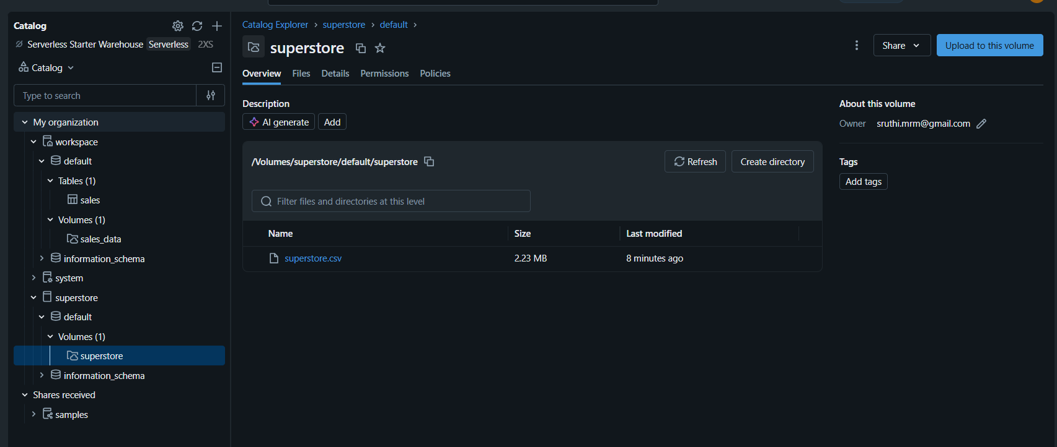
The volume after upload.

4. Bronze layer
The Bronze table holds the file as it arrived. I did not filter or correct anything at this stage. The only change was to the column names, because two of them (Ship _Date and Product_ ID) contain a space and Delta refuses to write columns with spaces in the name.
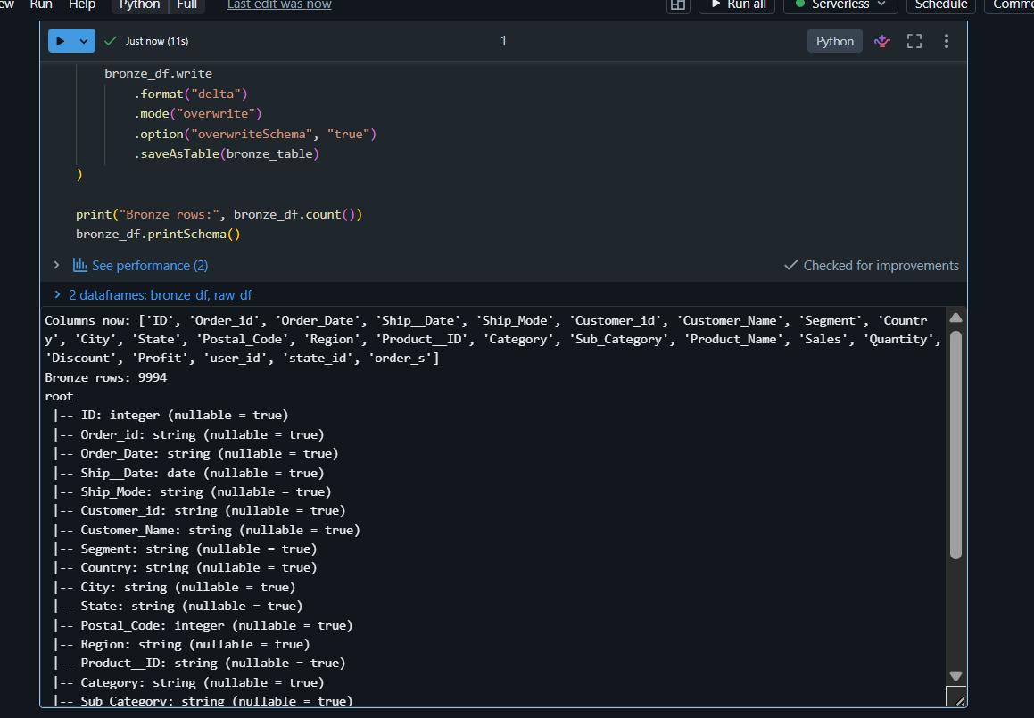
Bronze loaded: 9,994 rows. Order_Date came through as string rather than date, which was the first sign of a problem in that column.

5. Silver layer
Silver is where the cleaning happens. I renamed the columns to lower case, dropped the three empty ones, cast the numeric columns, and repaired the dates.
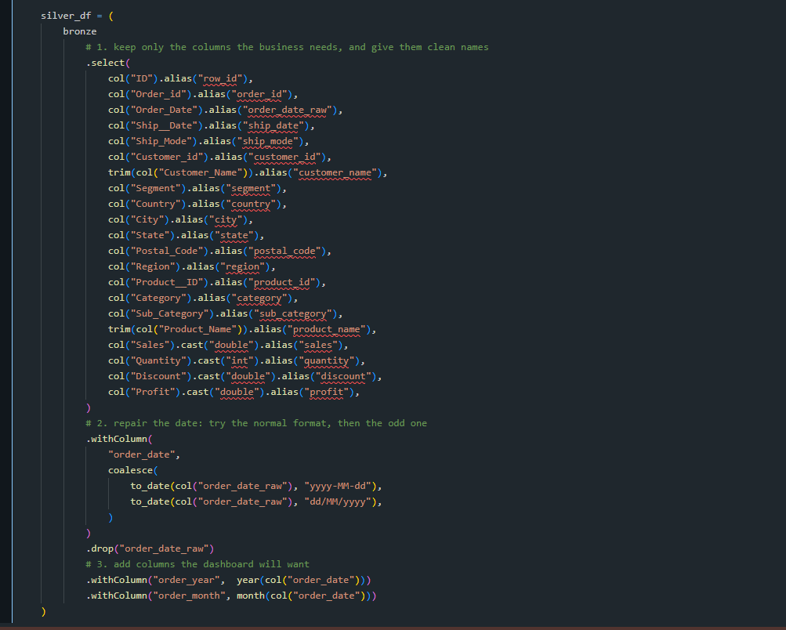
The select statement that renames the columns and drops the unused ones.
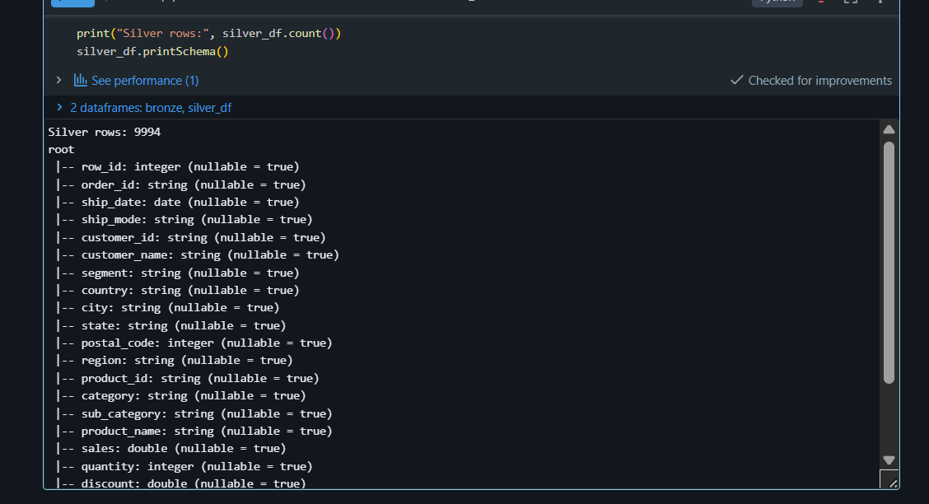
Silver schema after cleaning. Column names are consistent, sales and discount are double, quantity is int.
One row still would not parse. It reads 29/02/2023, and 2023 was not a leap year, so that date does not exist and no parser can fix it. Rather than dropping it silently I wrote it to a separate quarantine table, so it can be counted and sent back to whoever owns the source system)
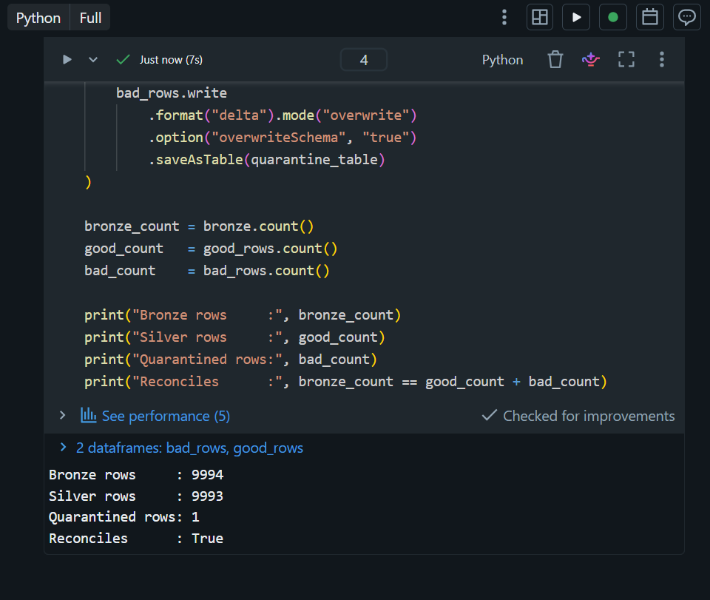
Reconciliation check. Silver plus quarantine equals Bronze, so no rows were lost.

6. Data issues found in the source file
Issue | Detail | What I did
Column names with spaces | Ship _Date and Product_ ID | Renamed at read time
Empty columns | user_id, state_id and order_s are blank in 9,992 of 9,994 rows | Left out of the Silver select
Invalid date | One row reads 29/02/2023, which is not a real date | Moved to a quarantine table
ID is not unique | IDs 2021 to 2024 each appear twice, but the paired rows are different from each other | Kept all rows, did not treat ID as a key
Encoding | Latin-1 characters in product names | Read with ISO-8859-1

Worth noting on the fourth point: because the repeated IDs belong to rows that differ from each other, there are no true duplicate rows in the file. Running dropDuplicates would have removed nothing and would have hidden the real finding, which is that ID cannot be used as a primary key.

7. Gold layer
Each business question gets its own small table. The four KPIs go in one table:
kpi_df = silver.agg(
countDistinct("customer_id").alias("total_customers"),
countDistinct("order_id").alias("total_orders"),
sum("sales").alias("total_sales"),
sum("profit").alias("total_profit")
)
countDistinct rather than count, because one customer appears on many rows.
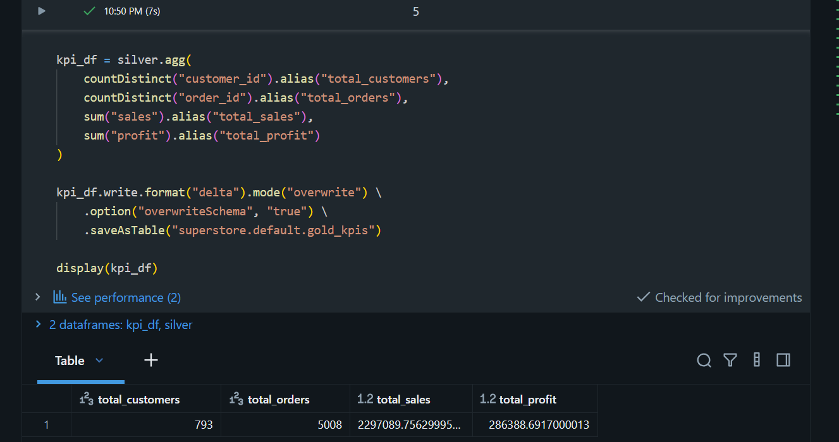
The four KPIs.
The rankings all follow the same four steps: group, aggregate, sort, save. Only the column being grouped on changes.
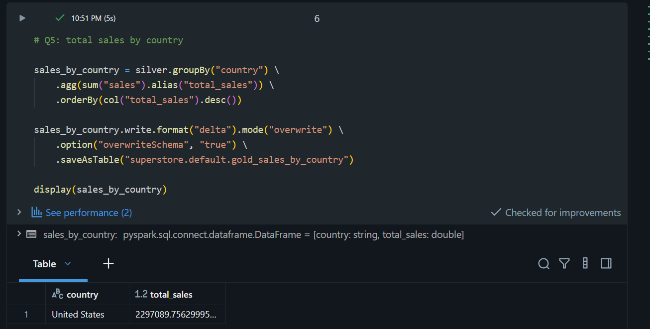
Sales by country. Every row in the dataset is United States, so this returns a single row.
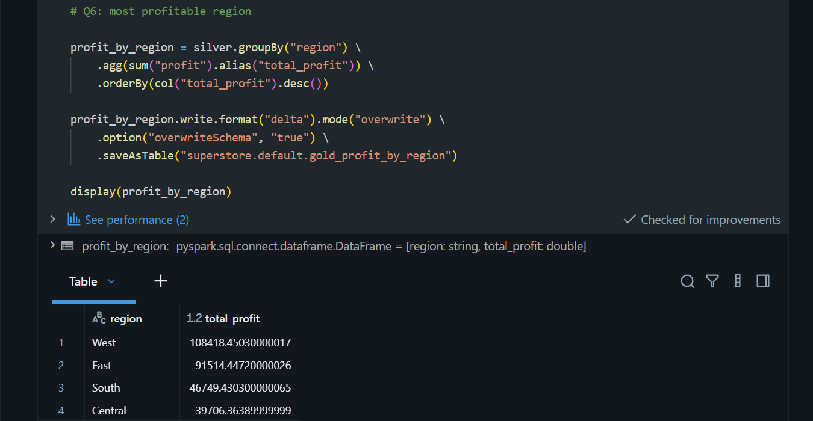
Profit by region. West is the most profitable.
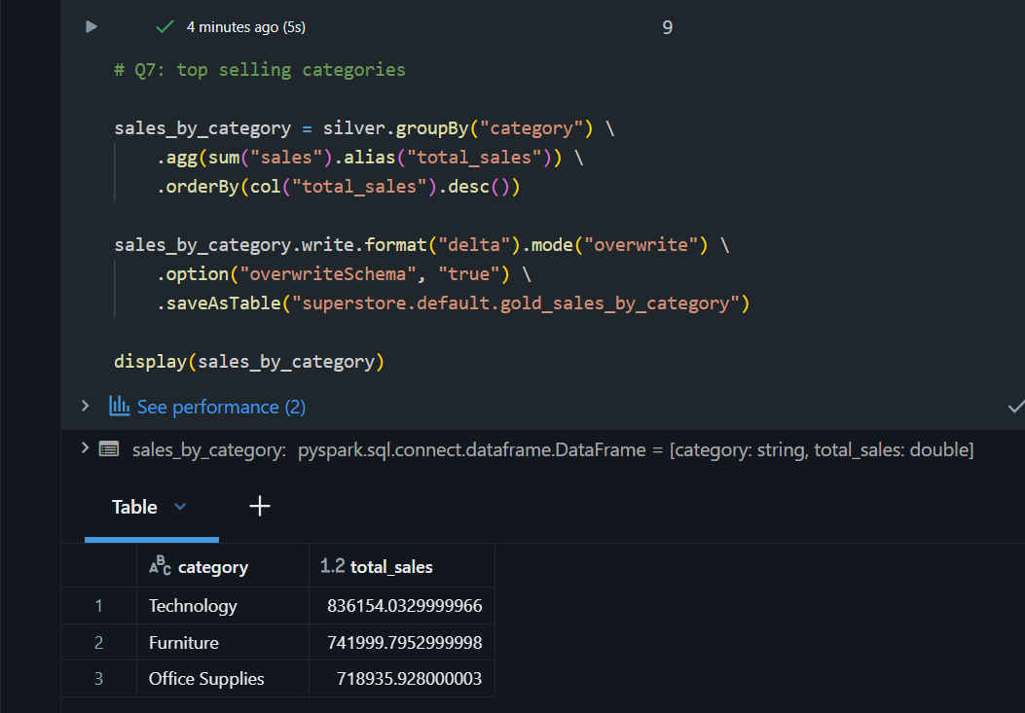
Sales by category. Technology leads.
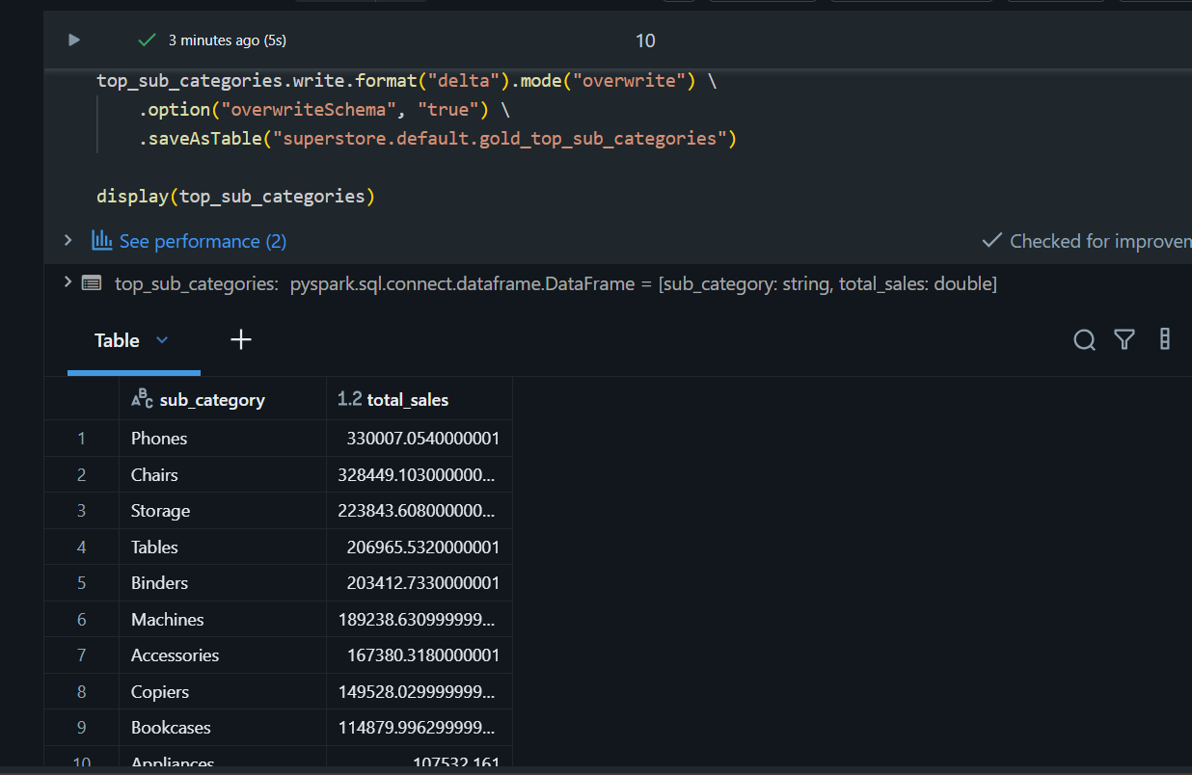
Top 10 sub categories by sales.
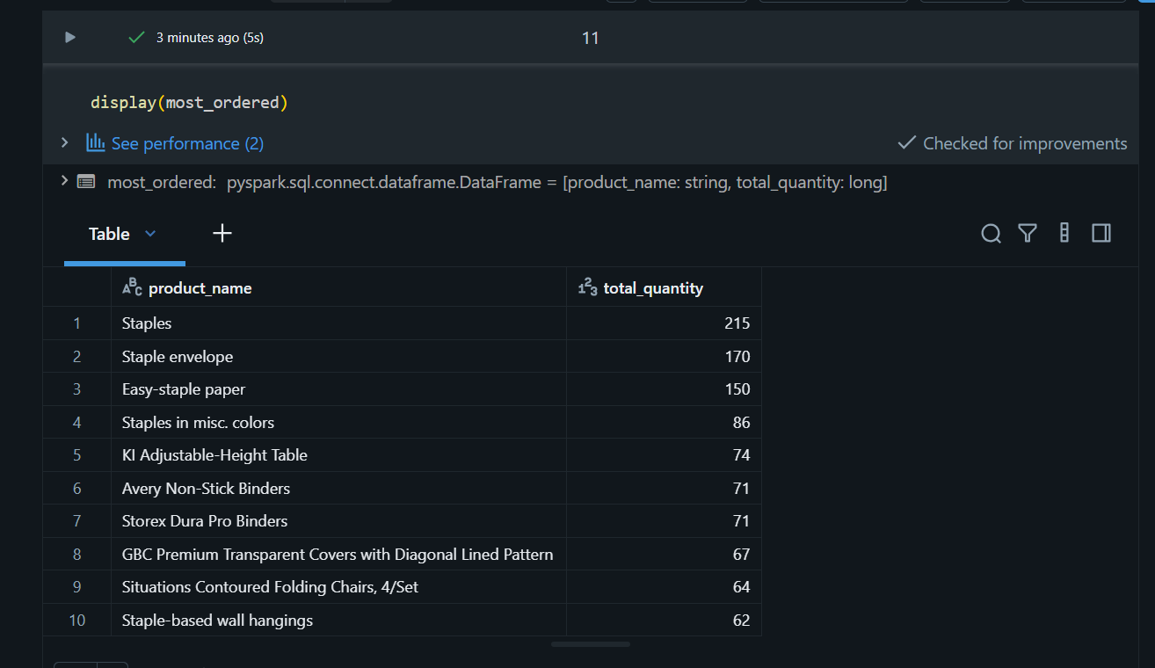
Most ordered products, ranked by quantity rather than by money.
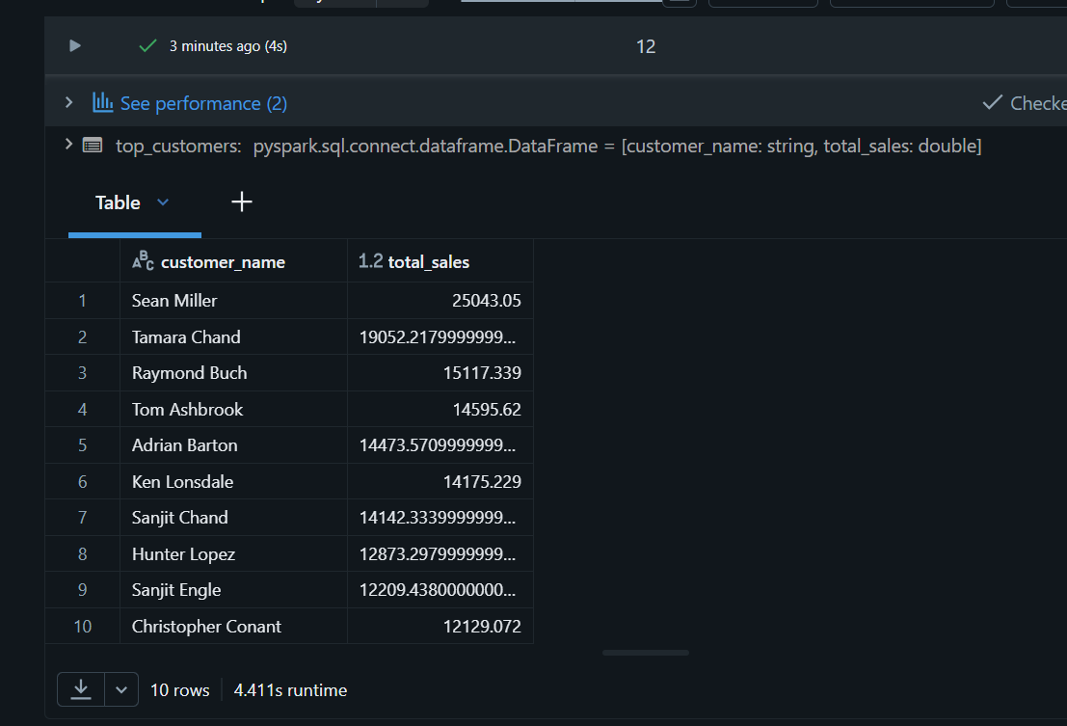
Top 10 customers by sales.
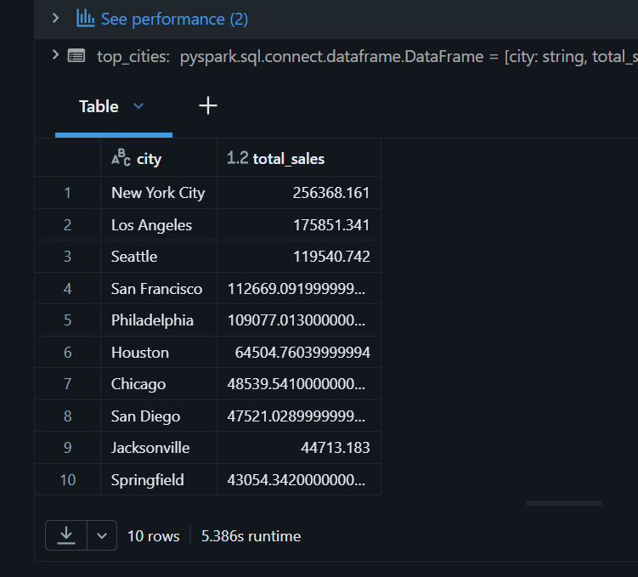
Top 10 cities by sales.
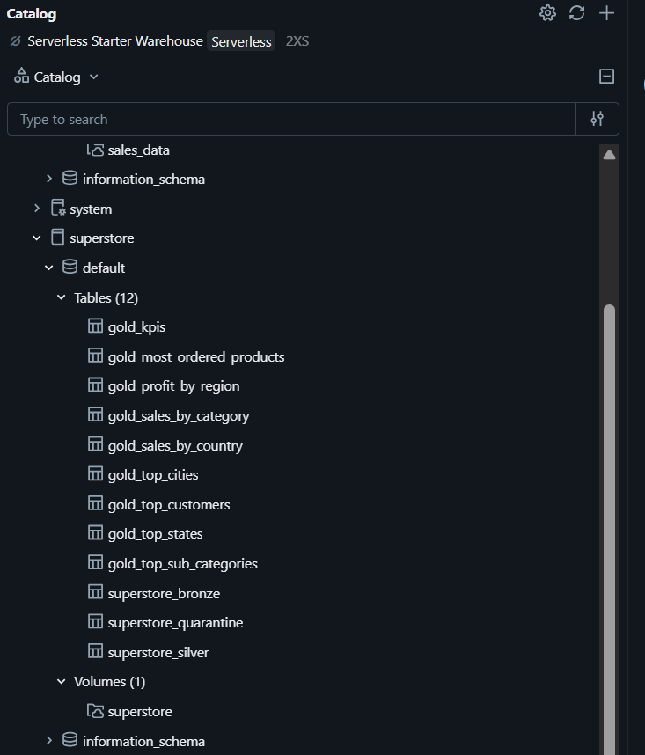
The finished catalog: three pipeline tables and nine gold tables.

8. Results
I checked every figure against a separate calculation run directly on the CSV outside Spark. They all matched.
Metric | Result
Total customers | 793
Total orders | 5,008
Total sales | 2,297,089.76
Total profit | 286,388.69
Top country | United States (all rows)
Top state | California, 457,687.63
Most profitable region | West, 108,418.45
Top category | Technology, 836,154.03
Top sub category | Phones, 330,007.05
Most ordered product | Staples, 215 units
Top customer | Sean Miller, 25,043.05
Top city | New York City, 256,368.16

9. Dashboard
The dashboard reads only the gold tables. Those are already aggregated down to a few rows each, so it loads instantly. If the widgets queried the silver table directly they would re-aggregate 9,993 rows on every page load, which does not matter at this size but would matter on a real dataset.
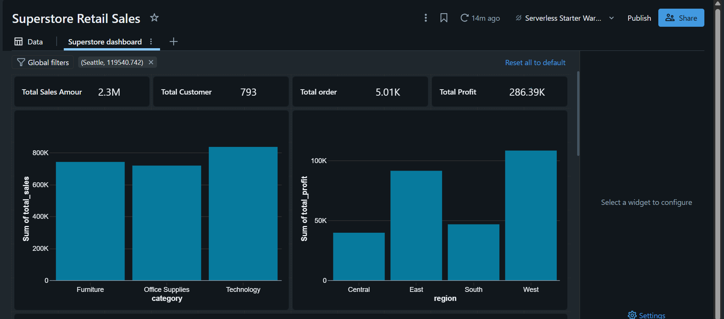
KPI counters, sales by category and profit by region.
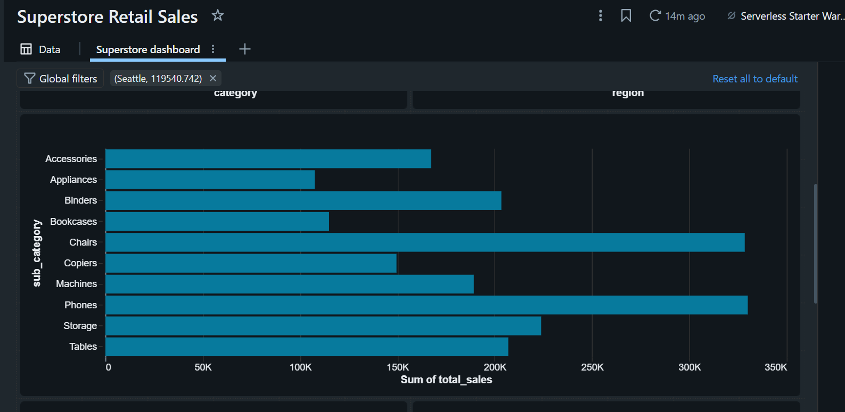
Top sub categories by sales.
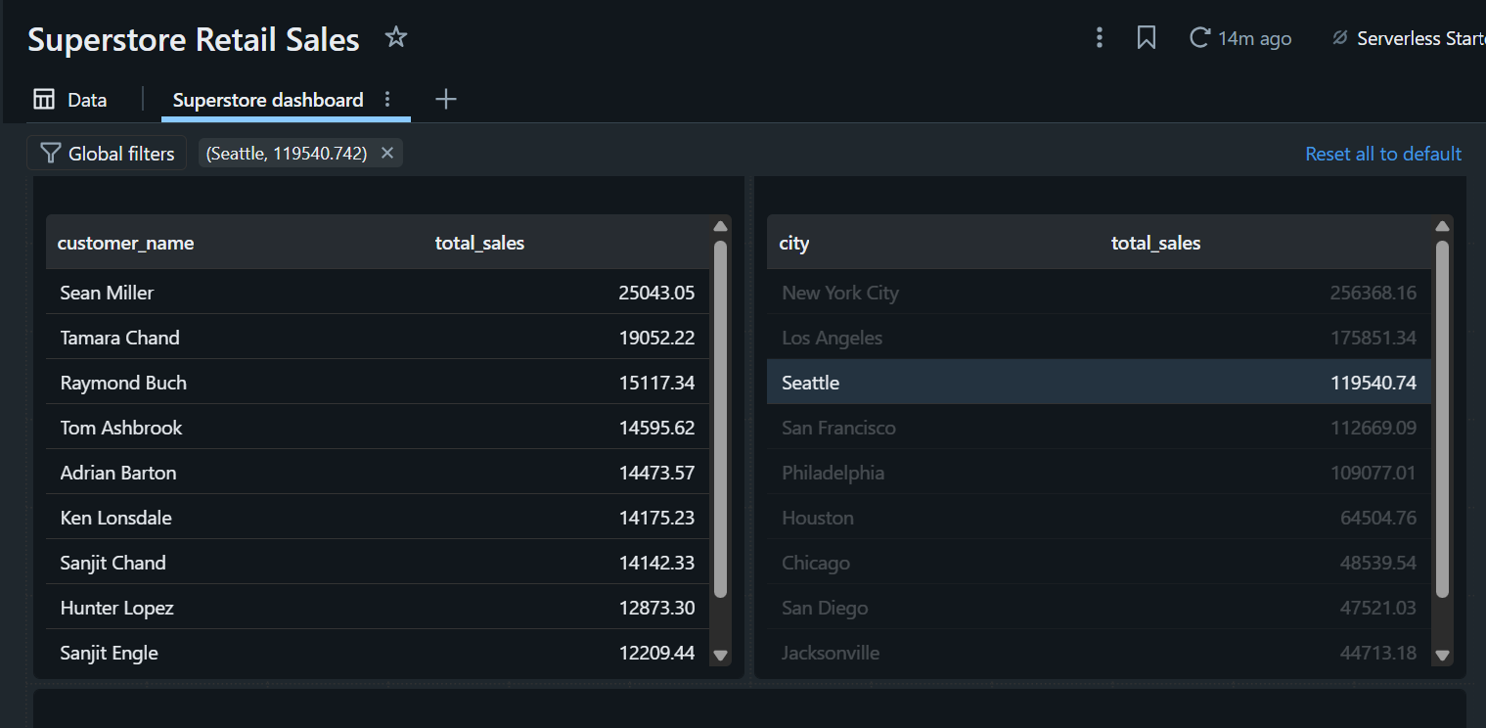
Top customers and top cities.
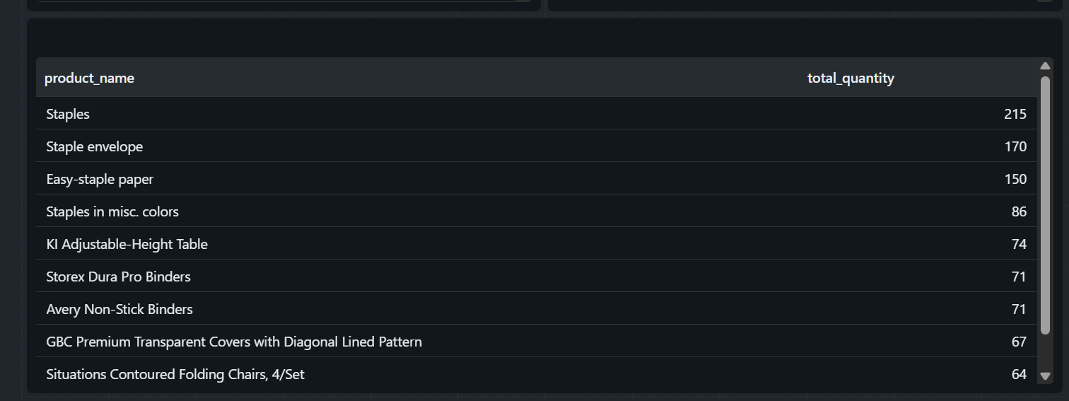
Most ordered products.
One thing to watch: clicking a row in a dashboard table cross filters the whole page, and that filter carries through to the published version. I had to clear it before publishing.

10. Scheduling
Two separate things need scheduling. The job rebuilds the tables, and the dashboard schedule re-runs the widget queries. The job has to run first, otherwise the dashboard refreshes against unchanged tables and reports success while showing old numbers.
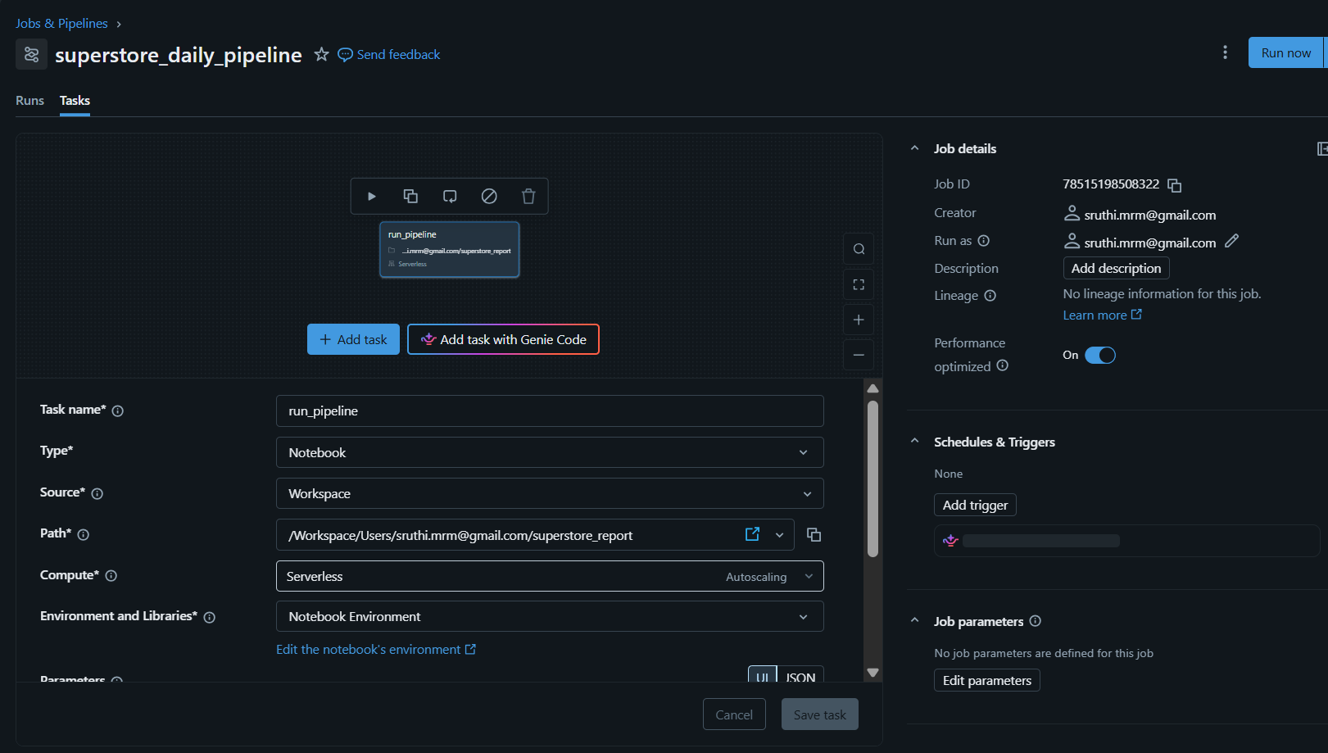
Job configuration: a single notebook task running on serverless compute.
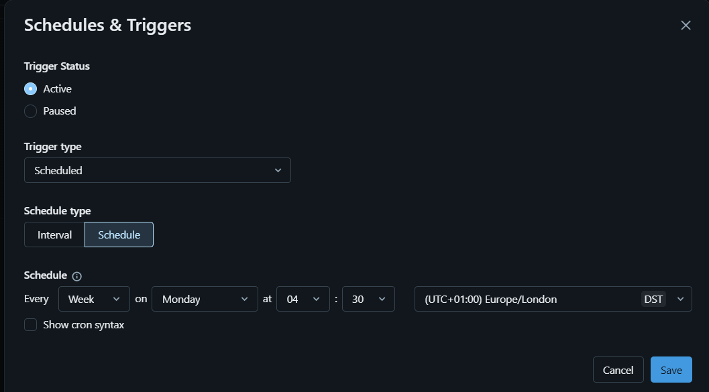
Weekly trigger, Monday at 04:30.
I also added a check at the end of the notebook. A scheduled run has nobody watching it, so if the source file goes missing and the read returns nothing, the job would otherwise finish green while writing empty tables.
silver_count = spark.table("superstore.default.superstore_silver").count()

print("Silver rows:", silver_count)

if silver_count == 0:
raise Exception("Pipeline produced an empty silver table")
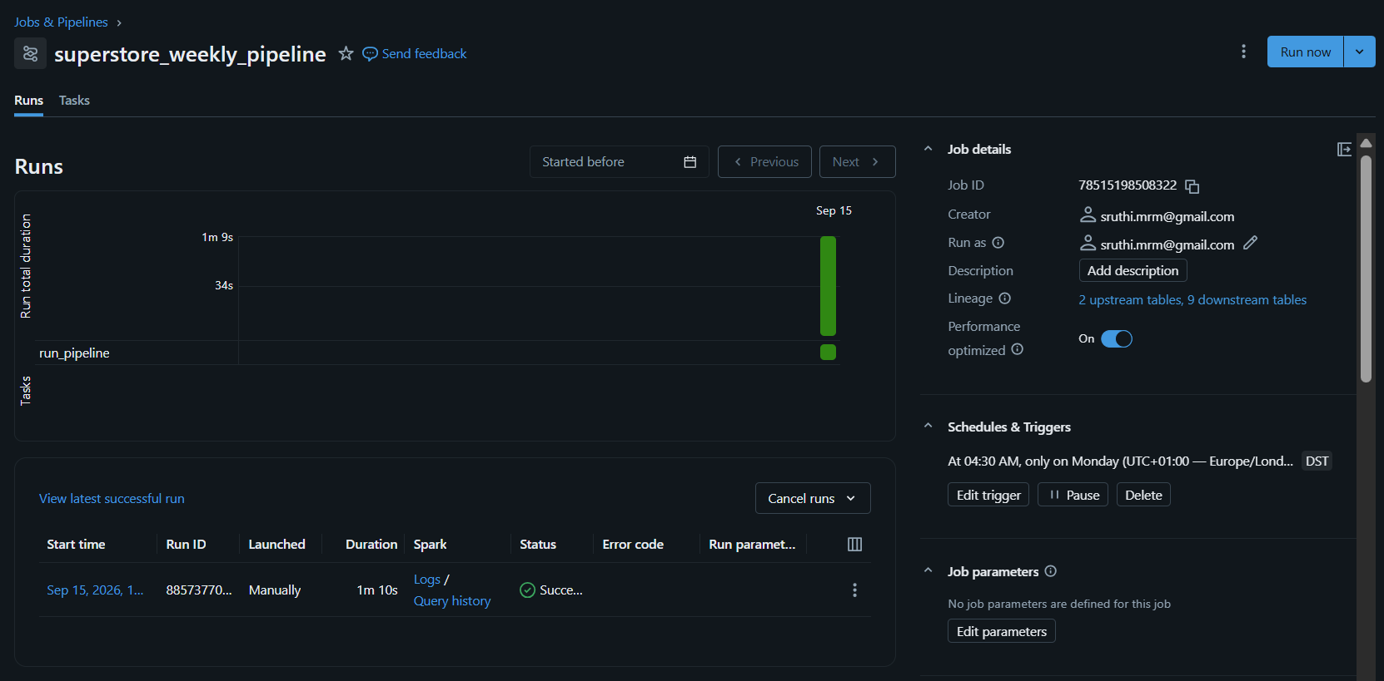
First run completed successfully in 1 minute 10 seconds. Lineage shows 2 upstream and 9 downstream tables.

11. What I would change for production
- Bronze currently overwrites the whole table each run. A real feed would append new files and use Auto Loader to track what has already been loaded.
- Money is stored as double, so values come out as 2297089.75629995. Decimal would be the correct type, with rounding applied when writing the gold tables.
- The quarantine table needs an alert on its row count. One bad row is nothing, a hundred means something upstream has broken.
- Since ID is not unique, the real grain is the order line. That should be stated and tested, otherwise someone will join on ID later and double their totals.

